
A FINAL YEAR RESEARCH PROJECT
ON
AUTONOMOUS LAWN MOWERS
PRESENTED TO
THE DEPARTMENT OF COMPUTING AND ENGINEERING SCIENCES
BY
WUYEP RAYNAN ABRAHAM 20/2115
ARAOYE TIMOTHY 20/1234
AJOKU OKECHUKWU 20/0697
IN PARTIAL FULFILLMENT OF THE REQUIREMENT FOR THE DEGREE OF A BACHELOR’S IN COMPUTER SCIENCE IN BABCOCK UNIVERSITY

SUPERVISED BY:
DR. ALAO
MARCH, 2024

DECLARATION
We declare that the project work, AUTONOMOUS LAWN MOWER was carried out by the following people:

WUYEP RAYNAN ABRAHAM
20/2115 Signature/Date

ARAOYE TIMOTHY
20/1234 Signature/Date

AJOKU OKECHUKKWU
20/0697 Signature/Date

CERTIFICATION
We hereby certify that this project was carried out by the under listed students under the supervision of Dr. Alao, in the Department of Computer Science, School of Computing and Engineering Sciences Babcock University, Ilisan-Remo, Ogun State, Nigeria.

WUYEP RAYNAN ABRAHAM 20/2115

ARAOYE TIMOTHY KOLAPO 20/1234

AJOKU OKECHUKWU 20/0697

DR. ALAO
Project Supervisor Date/Signature

DR. KUYORO SHADE O.
Head of Department Date/Signature

External Supervisor Date/Signature

DEDICATION
This Project is dedicated to the Almighty God, who has helped us and granted us wisdom, knowledge and understanding from the start of this project to the very end. This project is also dedicated to our sponsors, Dr. Alao, our supervisor, and our parents for their unwavering support. Dr. Alao has provided constant direction and assistance throughout this project.

ACKNOWLEDGMENT
God, the source of all knowledge and wisdom, has been our guide and strength throughout this project. We offer our sincerest gratitude to Him for providing us with the courage and perseverance to complete this task. We would also like to express our appreciation to our supervisor, Dr. Alao, for his unwavering support and guidance in shaping our research. His encouragement and constructive feedback have been instrumental in shaping the outcome of this project. I also thank Babcock University and the Department of Computer Science for providing resources for our research. Our deepest gratitude goes to our families, friends and lecturers for their constant encouragement and for making our project become a reality. Without their unwavering support, this project would not have been possible. Lastly, we dedicate this work to anyone who is on a journey to seek knowledge and understanding. May this project inspire and motivate others to push beyond their limits and achieve their goals.

TABLE OF CONTENT
CHAPTER ONE: INTRODUCTION
1.1 Background of Study —---------------------------------------------------------------8
1.2 Statement of the Problem —---------------------------------------------------------9 1.3 Aim & Objectives —-----------------------------------------------------------------9 1.4 Methodology Overview —-----------------------------------------------------------10 1.5 Scope of Study —----------------------------------------------------------------------11 1.6 Significance of Study —--------------------------------------------------------------12 1.7 Definition of Terms —----------------------------------------------------------------13

CHAPTER TWO: LITERATURE REVIEW
2.0 Introduction —--------------------------------------------------------------------------14
2.1 Historical Background of Research —----------------------------------------------14
2.2 Overview of Existing System —-----------------------------------------------------15
2.3 Review of Related Work—-----------------------------------------------------------19
2.4. Summary of Reviewed Literature —-----------------------------------------------23
2.5 Good Comments —--------------------------------------------------------------------23

CHAPTER THREE: RESEARCH METHODOLOGY
3.1 Introduction —--------------------------------------------------------------------------24
3.2. Research Design —--------------------------------------------------------------------24
3.3 System Block Diagram —-------------------------------------------------------------25
3.4. System Operation—-------------------------------------------------------------------26
3.5. Functional and Non-Functional Requirements —---------------------------------26
3.6. Proposed Model Design —------------------------------------------------------27
3.6.1. Stamp Microcontroller —--------------------------------------------27
3.6.2. Power Adapter—------------------------------------------------------28
3.6.3 12V Battery Supply —------------------------------------------------29
3.6.4. Ultrasonic Sensor —--------------------------------------------------30
3.6.5. 5V Regulator—--------------------------------------------------------31
3.6.6. Cutting Blade Driver —----------------------------------------------32
3.6.7 Machine Eye —--------------------------------------------------------33
3.6.8 L293d Motor Driver —-------------------------------------------------33
3.6.9 DC Motor —--------------------------------------------------------------34

CHAPTER 4: SYSTEM IMPLEMENTATION

CHAPTER 5: SUMMARY, RECOMMENDATION AND CONCLUSION

REFERENCES

CHAPTER ONE
INTRODUCTION
1.1 BACKGROUND TO THE STUDY
The history of automated lawn mower is a fascinating topic that shows the evolution of technology and human creativity. According to various research conducted, here are some of the main milestones and events in the history of automated lawn mower.
The first patent for a mechanical lawn mower was granted to Edwin Beard Budding, an English engineer, in 1830. His design was based on a tool used to cut carpet, and consisted of a series of blades around a cylinder. He partnered with John Ferrabee, a manufacturer, to produce and sell his invention.
The first gasoline-powered lawn mower was invented by John Burr, an American inventor, in 1899. His design improved the previous models by adding a rotary blade and a traction wheel. He also patented a lawn mower clutch that allowed the operator to disengage the blade without stopping the engine.
The first electric lawn mower was introduced by the American Lawn Mower Company in 1926. It was powered by a long cord that connected to an electrical outlet. It was lighter and quieter than the gasoline-powered lawn mowers, but it had limited range and mobility.
The first solar-powered lawn mower was patented by André Collens, a Belgian inventor, in 1992. He sold his patent to Husqvarna, a Swedish company, which marketed it in 1995. It was the first fully autonomous lawn mower that used solar panels to charge its batteries and sensors to navigate the lawn.
The first robotic lawn mower with lawn mapping was introduced by Bosch, a German company, in 2012. It was called Indego and it used a systematic mowing pattern instead of a random one. It also had features such as obstacle detection, theft protection, and weather resistance.
The first vision-based robotic lawn mower without perimeter wire was announced by iRobot, an American company, in 2019. It was called Terra and it used cameras and artificial intelligence to map and mow the lawn. It also had features such as wireless charging, smartphone control, and custom schedule.

1.2 STATEMENT OF THE PROBLEM
Although there have been advancements in mechanical farming and gardening, Babcock University still encounter significant challenges in maintaining an adequate environment. This study shows that there is a critical gap that that exist in the availability of accessible resources and user-friendly tools that enables Babcock Association of Farmers And Gardeners (BAFG) to be able to carry out their tasks adequately.

Lawn care and maintenance is a tedious and time-consuming task for many homeowners, especially those who have large or irregular lawns. Manual lawn mowers require physical effort and constant supervision, while conventional electric or gas-powered lawn mowers are noisy, expensive, and polluting. Moreover, both types of lawn mowers are unable to adapt to different terrain conditions, grass heights, and weather situations. Therefore, there is a need for an automated lawn mower that can operate autonomously, efficiently, and eco-friendly on various types of lawns. The aim of this project is to design and develop an automated lawn mower that can use solar power, IoT technology, and path planning algorithms to mow lawns without human intervention. The project will focus on the following aspects: the mechanical structure and components of the lawn mower, the electrical circuit and power system, the communication and control system, and the software and algorithm development.

The project will also consider the safety, reliability, and usability of the lawn mower. The expected outcome of this project is a prototype of an automated lawn mower that can demonstrate its functionality and performance on a simulated lawn environment. The project will contribute to the advancement of robotics and automation technology, as well as provide a practical and innovative solution for lawn care and maintenance.

1.3 AIM AND OBJECTIVE OF THE STUDY
The aim of the project is to design and build an automated lawn mower that meets the needs of the Gardeners and farmers in Babcock University. The specific objectives of the study are to:
i. Conduct a literature search on the overall gardening and farm output
ii. Design and Build an automated lawn mower that meets the needs of the gardeners and farmers in Babcock university.

1.4 METHODOLOGY OVERVIEW

This study starts by thoroughly examining the steps in building the automated lawn mower through a thorough literature search. A wide range of sources, including published articles, research papers, expert interviews, case studies, and regulatory documents, are used to derive insights into the problem and a minimum of 10 current articles from 2020 to 2023 that are exclusively about the systematic and critical evaluation of the methods and techniques used to design and develop an automated lawn mower.

The second phase of this project will focus on The project consists of four main stages: design, fabrication, testing, and evaluation. The design stage involves selecting and sketching the components and dimensions of the lawn mower, such as the chassis, the wheels, the blades, the sensors, the solar panel, the battery, the wireless module, the GPS module, and the microcontroller. The fabrication stage involves cutting, drilling, welding, and assembling the parts of the lawn mower using metal or plastic materials and tools. The testing stage involves checking the functionality and performance of the lawn mower on different types of grass and terrain conditions using a simulated lawn environment. The evaluation stage involves analyzing the results and feedback from the testing stage and making improvements or modifications if needed.
The project uses various methods and techniques to achieve its objectives, such as:

I) Mechanical engineering principles and calculations to determine the optimal size, shape, weight, and balance of the lawn mower components.
II) Manual tools such as hammers, saws, drills, wrenches, etc. to assemble and adjust the parts of the lawn mower
III) Quality control measures such as inspection, measurement, alignment, etc. to ensure the proper functioning and safety of the lawn mower
V) Battery system to store excess energy and supply power when needed
VI) Charging station to recharge the battery when it is low
XI) Microcontroller system to control the operation and navigation of the lawn mower
XII) Image recognition system to identify obstacles and avoid collisions
XIII) Path planning algorithm to optimize the mowing route and coverage
XIV) User interface system to provide user feedback and options

The project follows a systematic and logical approach to design and develop an automated lawn mower that can meet the needs and expectations of the users. The project also considers the environmental and economic aspects of the lawn mower, such as reducing fuel consumption, emissions, and costs. The project aims to provide a practical and innovative solution for lawn care and maintenance.

1.5 SCOPE OF THE STUDY
This study is centered on the design and construction of an automated lawn mower aimed at addressing the challenges posed by gardeners and farmers within Babcock University. In this study, there will be an evaluation of the effectiveness and usability of the implementation of the automated lawn mower
LIMITATION OF STUDY
The automated lawn mower will focus exclusively on moderate lawns and will not consider any lawns that are above moderate or bushy lawns. Additionally, the automated lawn mower will require a lot of maintainance.
Expectations:
To build and program a fully functional automated lawn mower that helps to cut moderate lawns and reduce human intervention in Babcock university.

1.6 SIGNIFICANCE OF THE STUDY
1.Saving time and energy An automated lawn mower can operate autonomously, efficiently, and eco-friendly on various types of lawns, without requiring manual labor or supervision. It can also reduce the need for frequent mowing, as it can cut the grass more evenly and regularly.
2.Improving lawn quality and appearance: An automated lawn mower can enhance the health and beauty of the lawn, by cutting the grass at the optimal height and frequency, avoiding scalping or overgrowth, and mulching the clippings to fertilize the soil.
3.Reducing environmental impact: An automated lawn mower can lower the carbon footprint and noise pollution of lawn care, by using renewable energy sources such as solar power or batteries, instead of fossil fuels or electricity. It can also prevent soil erosion and water runoff, by maintaining a dense and uniform turf.

4.Providing convenience and safety: An automated lawn mower can offer a user-friendly and customizable experience, by allowing remote monitoring, control, and tracking via wireless communication or smartphone app. It can also prevent injuries or accidents, by using sensors and algorithms to avoid obstacles and collisions.

1.7 DEFINITION OF TERMS
1. Autonomous- independent and having the power to make your own decisions.

2. Lawn- ground (as around a house or in a garden or park) that is covered with grass and is kept mowed.

3. Mower- A mower is a person or machine that cuts (mows) grass or other plants that grow on the ground.

4. Sensor- A device that allows the mower to perceive its environment and react accordingly. Sensors can help the mower avoid obstacles, detect rain, adjust speed, and communicate with the user.

5. Mulching- A process that involves cutting the grass into very small pieces and leaving them on the lawn. Mulching can provide natural fertilization and moisture for the soil.

6.Blade- A sharp metal part that rotates and cuts the grass. Blades can vary in size, shape, and number, depending on the model and the performance of the mower.

CHAPTER TWO
LITERATURE REVIEW
2.0 INTRODUCTION
In this chapter, we provide an extensive review of the existing literature on autonomous lawnmowers. We aim to identify the various methodologies and techniques employed by researchers to develop autonomous lawnmowers. Furthermore, we discuss the different data sources used to train and validate these models. Finally, the review explores the significance of autonomous lawnmowers in minimizing operator fatigue and reducing the negative environmental impact of traditional lawnmowers.
2.1 HISTORICAL BACKGROUND TO RESEARCH
A lawn mower is a machine used to cut grass to an even height. It is typically used on a lawn or yard and is powered by electricity, gasoline, or battery. Lawn mowers come in different types such as push mowers, riding mowers, and robotic mowers. They are commonly used to maintain the appearance of a yard or lawn.
The history of lawnmowers, in general, can be traced back to the 1890s when steam-powered lawnmowers appeared. In 1902, Ransomes produced the first commercial lawn mower powered by an internal combustion gas engine[2]. In the U.S., gas-powered mowers were first manufactured in 1915 by Ideal Power Lawn Mower Co. of Lansing, Michigan, based on a patent by Ransom Eli Olds[2]. After World War II, gas-powered mowers were more popular, helping create the middle-class vogue for manicured lawns[2].
The history of autonomous lawn mowers can be traced back to the invention of the first self-propelled lawn mower in 1969 by S. Lawrence Bellinger under Mowbot, Inc. [2]. However, the first fully solar-powered robotic mower was patented by André Collens in 1992 and sold to Husqvarna, which marketed it in 1995[1]. In the early 1990s, the Husqvarna Group began working on a robotic lawn mower prototype, and the first model called the Solar Mower, was introduced in 1995[3]. The first commercial version of the Automower was introduced in 1998, which was called the Automower Solar Hybrid and was powered by a rechargeable battery[3]. In 2012, the Bosch Indego introduced lawn mapping to mow systematically instead of a random pattern[1]. As of 2019, vision-based Artificial Intelligence robotic mowers, without perimeter wire, were announced by EEVE, followed by a vision-based robotic mower of Volta in 2019[1]. Today, robotic lawnmowers are increasingly sophisticated, are self-docking, and some contain rain sensors, nearly eliminating human interaction[1].
2.2 OVERVIEW OF EXISTING SYSTEMS
There exist several lawn mowing systems that have been around for over a century. Here is an overview of some of the existing lawn mowing systems:
2.2.1 MANUAL PUSH MOWERS
Manual lawn mowers are a great option for people who are looking for a more environmentally friendly and affordable way to mow their lawn. They are also a good choice for people who have small lawns or who prefer to get some exercise while they mow. Manual lawnmowers come in two main types: reel mowers and rotary mowers. Reel mowers have a series of blades that rotate against a stationary blade, cutting the grass like a pair of scissors. Rotary mowers have a single blade that spins rapidly, cutting the grass like a knife. Reel mowers are generally quieter and more environmentally friendly than rotary mowers. They also produce a cleaner cut, which can help to improve the overall health of your lawn. However, reel mowers can be more difficult to use on uneven lawns or lawns with tall grass.
Rotary mowers are more powerful and easier to use than reel mowers. They can also handle taller grass and uneven lawns more easily. However, rotary mowers can be louder and more polluting than reel mowers.
- Disadvantages: requires physical effort, is not suitable for large lawns, and can be time-consuming.
2.2.2. GAS-POWERED MOWERS
Gas-powered mowers have been around since the early 20th century. The first gasoline-powered lawn mower was developed in 1902 by Ransomes, Sims & Jefferies, a British engineering company.
In the United States, the first gas-powered mower was created by Colonel Edwin George in 1919. This invention marked the transition from manual and horse-drawn mowers to motorized alternatives.
Over the decades, improvements in engine technology, design, and materials have made gas-powered mowers more efficient, reliable, and widely used for maintaining lawns of various sizes.
While gas mowers are still popular today, there is a growing interest in electric and battery-powered mowers due to environmental concerns and advancements in battery technology, which offer quieter and more eco-friendly alternatives to traditional gas mowers.
These mowers are powered by an internal combustion gas engine and are more powerful than manual push mowers. They are suitable for larger lawns and can handle tough grass and weeds.
- Disadvantages: noisy, polluting, require regular maintenance, and can be expensive to operate.
2.2.3. ELECTRIC MOWERS:
Electric mowers have a history that dates back to the early 20th century, with some of the earliest models appearing in the 1920s and 1930s.
Initially, corded electric mowers were the primary type available, requiring a constant connection to a power source. These mowers were quieter and more environmentally friendly compared to gas mowers.
The development of rechargeable battery technology in the latter half of the 20th century allowed for the introduction of battery-powered electric mowers. This advancement made electric mowers even more convenient and mobile, eliminating the need for cords.
Today, electric mowers have become increasingly popular due to their eco-friendliness, lower noise levels, and ease of use. They are often considered a more sustainable and quieter alternative to gas-powered mowers, particularly for smaller to medium-sized lawns. Advances in battery technology have extended the runtime and power of electric mowers, making them a viable option for many homeowners.
These mowers are powered by electricity and are quieter and more environmentally friendly than gas-powered mowers. They are suitable for small medium-sized lawns and require less maintenance than gas-powered mowers. They are available in corded and cordless models.
- Disadvantages: corded models have a limited range, cordless models have limited battery life and can be expensive to purchase.
2.2.4. RIDING MOWERS:
The concept of riding mowers can be traced back to the early 20th century when the first lawn tractors were developed. These early models were often based on agricultural tractors adapted for lawn care.
In the 1950s, companies like John Deere and International Harvester introduced dedicated lawn and garden tractors designed for residential use. These machines were more compact and user-friendly than their agricultural counterparts.
Over the years, riding mowers evolved in terms of design, comfort, and functionality. They became popular for homeowners with larger lawns, as they could significantly reduce the time and effort required for mowing.
Modern riding mowers are available with a wide range of features, including attachments for tasks like snow removal and lawn aerating. Some models even come with zero-turn capabilities, allowing for precise maneuvering around obstacles.
Riding mowers have become an integral part of lawn care equipment, particularly for those maintaining substantial or complex landscapes. They provide efficiency and comfort while mowing larger areas, making them a valuable tool for homeowners and professional landscapers alike.
These mowers are suitable for large lawns and are powered by gas or electricity. They are more expensive than push mowers and require more storage space. They are available in different sizes and can be used for other tasks such as snow removal and hauling.
- Disadvantages: expensive to purchase, require more storage space, and can be noisy and polluting.
In conclusion, while non-autonomous lawn mowing systems have their advantages, they also have some disadvantages. These disadvantages include physical effort, noise, pollution, regular maintenance, limited range, limited battery life, and high costs. The choice of a lawn mower depends on the size of the lawn, the type of grass, and personal preferences.
2.3 REVIEW OF RELATED WORK
2.3.1 WORX LANDROID M 20V 4.0AH ROBOTIC LAWN MOWER:
The Worx Landroid is an autonomous lawn mower powered by a rechargeable 20-volt (V) battery. It uses intelligent navigation software to mow in a random pattern while covering the entire lawn for a week. A perimeter wire keeps the mower in bounds as it quietly mows on an automated or customized schedule, which can be anytime, day or night. When mowing is complete, or when the battery runs low, Landroid returns to its charging station.
Landroid’s sensors help it work safely and efficiently. An onboard rain sensor pauses the mowing schedule during precipitation. Bump sensors and the optional Anti-Collision System help it avoid obstacles on the lawn such as toys and patio furniture.
Although users have the option of programming a customized mowing schedule, one of Landroid’s most advanced features is its IoT-based Auto Scheduler. (IoT refers to the “internet of things,” which is the interconnection of objects that have computing devices embedded within them to exchange information over the internet.) It uses features such as lawn size, grass species, soil type, and irrigation, along with weather information, to create a personalized mowing schedule that it constantly adjusts. Once it’s set, users can simply load any exclusions for days or times when the mower is not allowed to work. Landroid is available in three models: Landroid S is for yards up to 5,445 square feet, Landroid M covers yards up to 10,890 square feet, and Landroid L mows yards up to 21,780 square feet. Although these mowers may be controlled manually with onboard control features, Wi-Fi connectivity, and the Landroid Mobile App allow users to monitor and control Landroid from anywhere and to make wireless software updates.
CONS
May not dock properly if the charging station is not perfectly flat and level with a level approach
2.3.2 ECOFLOW BLADE:
The EcoFlow Blade is a robotic lawn mower and sweeper that is equipped with advanced technology. Here are some key features and reviews of the EcoFlow Blade:
-Camera and LIDAR sensor: The EcoFlow Blade has a camera and LIDAR sensor to detect obstacles and avoid collisions.
-Enhanced GPS: The mower uses centimeter-accurate enhanced GPS for defining lawn borders without wire.
-Omnidirectional wheels: The EcoFlow Blade has omnidirectional wheels for precise maneuvering.
-AI route planning: The mower uses AI to plan straight-line mowing routes, rather than the typical robot mower zigzag pattern.
- Electronically height-adjusted blades: The EcoFlow Blade has electronically height-adjusted blades that can evenly trim the lawn with no missed patches.
-Lawn sweeper: The EcoFlow Blade also has a lawn sweeper that can sweep the lawn after mowing.
- Battery and solar panel solution: EcoFlow offers a battery and solar panel solution to run the mower off-grid.
Reviews:- The Technology Man reviewed the EcoFlow Blade and found that it worked far better than expected. The GPS mapping worked well, and the mower did a good job on both tricky lawns with its large wheels, floating blades, and AI route planning. The lawn sweeper also did a great job.
- AppleInsider(2023) reviewed the EcoFlow Blade and found that it was a great robot mower for very specific lawns. The Blade has many features built-in to stand the test of many seasons chopping grass, including LiDAR obstacle avoidance sensors, wire-free boundaries, route planning, and a 10-inch cutting distance. However, the testing of the Blade was severely limited by the characteristics of the lawn, impacting connection and use.
- PCMag reviewed the EcoFlow Blade and found that it was an easily programmable and rugged robotic lawn mower that operates without perimeter wires. The Blade uses Real Time Kinematic (RTK) GPS technology to navigate the lawn without wires. However, its base station and antenna must have a clear view of the sky, so it might not be able to use it if the property has lots of tall trees or lacks wide-open space.
- TechCrunch(2023) reviewed the EcoFlow Blade and found that it was cheaply built, suffered from terrible software, and the installation was far from advertised. The reviewer was disappointed and frustrated with the EcoFlow Blade and could not recommend the unit. The company has shipped a handful of firmware updates that have improved the Blade's functionality, but fundamental problems remain, from its design to competitive features at its high price point.
Overall, the EcoFlow Blade has many advanced features and capabilities, but it may not be suitable for all lawns. The reviews are mixed, with some reviewers finding it to be a great robot mower, while others were disappointed with its performance and software.
2.3.3 HONDA MIIMO 520
(Gardener’s World 2019) The Honda Miimo 520 is a robotic lawn mower that has several features and capabilities. Here are some key points from the reviews:
The Honda Miimo 520 is a well-made mower that is smooth, quiet, and efficient. It is easy to program and can tackle large and sloping lawns. The Honda Miimo 520 has a larger recommended area and wider cutting width than the average robotic lawn mower. It has a slope performance of 45% and can handle oddly shaped gardens with slopes up to 24°. The Honda Miimo 520 has a motor setup that includes a 25W motor to cut the grass and a 10W motor on each of the two wheels, making it very maneuverable. The mower runs almost silently and does not need cleaning, except for a quick check-up once a year to replace the blades. It is easy to set up, very low maintenance, good at navigating obstacles and slopes and offers minuscule running costs. The Honda Miimo 520 is a high-quality product that does exactly what you expect it to do, but it is not cheap. Overall, the Honda Miimo 520 is a great option for those who see mowing as a chore and want a high-quality, efficient, and easy-to-use robotic lawn mower
.
2.4 SUMMARY OF REVIEWED LITERATURE
The purpose of the Literature Review section was to take a look at previously designed Autonomous Lawn Mowers. A literature review gives multiple results on the benefits and disadvantages of using autonomous lawnmowers and previously constructed models. The most closely related work regarding the issue intended to be tackled by this project is presented in this segment.
2.5 GENERAL COMMENTS
Autonomous lawnmowers have become increasingly popular in recent years due to their ability to operate without human intervention. They offer many benefits as compared to the traditional lawnmower types discussed in this chapter, including reduced operator fatigue, lower running costs, and reduced noise pollution. These mowers incorporate advanced technologies such as artificial intelligence, proximity sensors, and GPS navigation to navigate around obstacles and mow lawns efficiently. Autonomous lawn mowers are also environmentally friendly since they don't produce harmful emissions like traditional lawn mowers. Overall, autonomous lawnmowers are a great innovation in lawn care technology and are poised to revolutionize the industry.

CHAPTER THREE
RESEARCH METHODOLOGY

3.1 INTRODUCTION
This chapter discusses the methods used in designing, implementing and building an autonomous lawn mower. It is a lawnmower that can function with little to no human interaction. In this chapter, hardware components, system block diagram, circuit diagram and system operation will be discussed.
3.2 RESERACH DESIGN
This chapter aims to build an autonomous lawn mower that can automatically function with litle to no human intervention using the help of sensors and a machine eye to guide its motion. In the construction of the autonomous lawn mower, to facilitate autonomy, a machine eye, ultrasonic sensors, microcontroller, motordriver and MOSFET current amplifiers would be used. A regulator, dc motor and servo motor would be used to enable movement and cutting capablities. The mower uses its machine eye to avoid obstacles and ultrasonic sensors to detect the level of grass and adjust the cutting blade accordingly. The lawnmower would contain several features such as; a power source, a voltage regulator, tyres, lithium-ion battery, several sensors and so on. All of these features would be further discussed in this chapter.

3.3 SYSTEM BLOCK DIAGRAM
A Block diagram is a very essential method used to develop and describe hardware or software systems as well as represent their workflows and processes. The system's block wiring diagram is shown below:
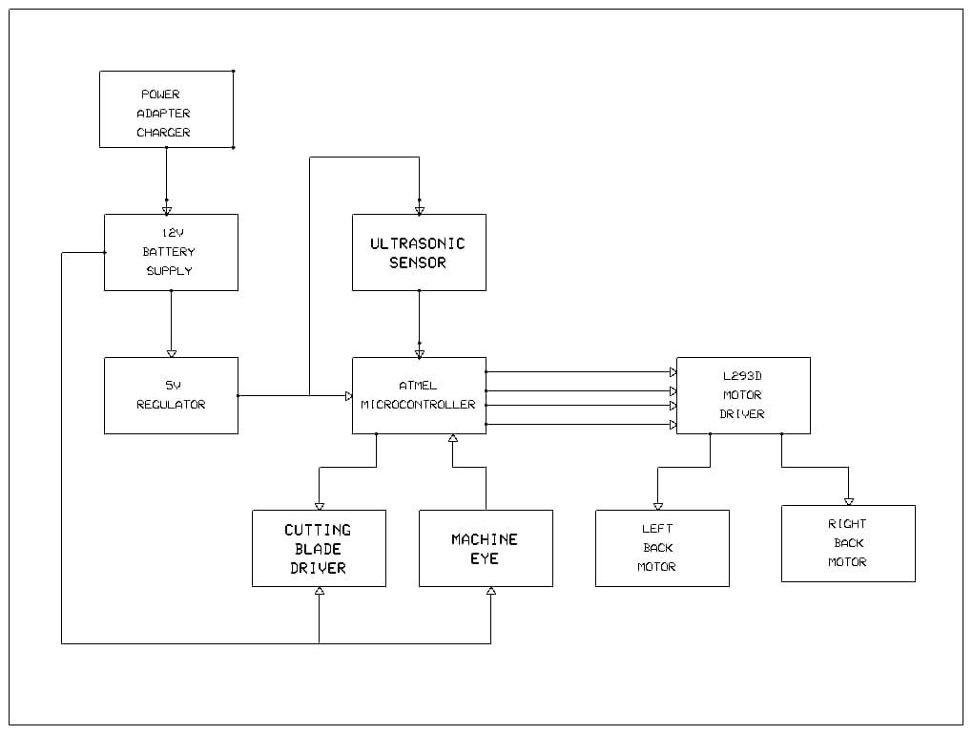

Figure 3.1
Below is the circuit diagram for the system:
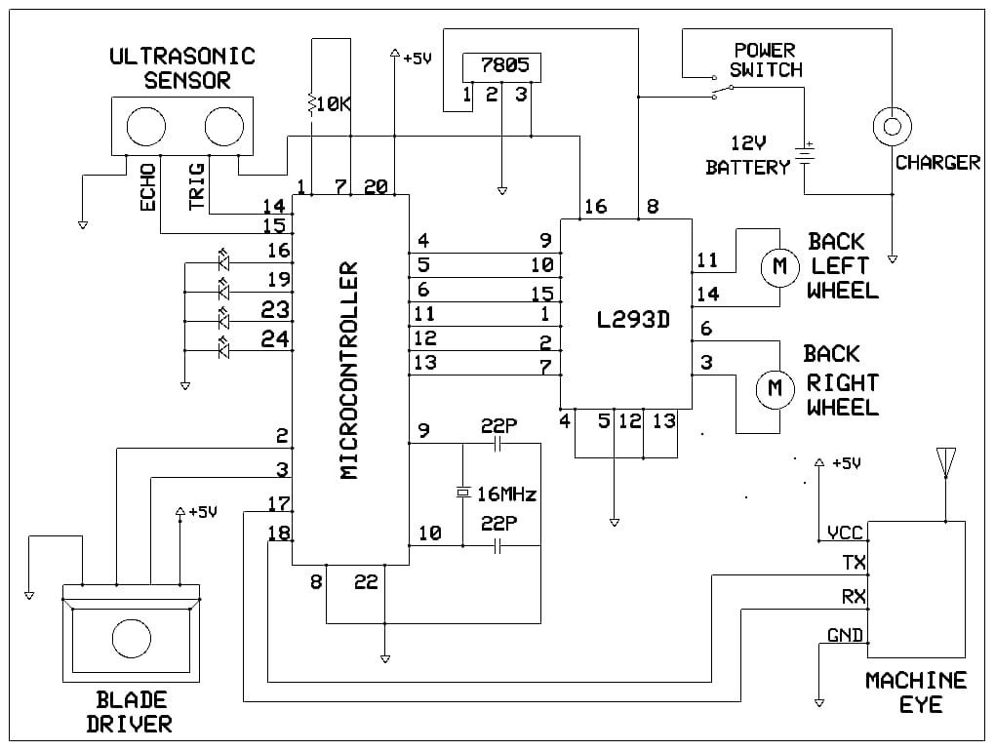
Figure 3.2
3.4 SYSTEM OPERATION
The major aim of the autonomous lawn mower is to eliminate the need for human interaction during the process of lawn care, saving time, energy and leaving little to no room for human error.
For the overall functioning of the lawnmower, a lithium-ion battery is necessary to power the box. The various sensors and machine eye are used to transmit the signals to the STM32 microcontroller and the motor drive to drive the DC Motors which are connected to the wheels and cutting blade. One of the biggest benefits of the mower is its ability to avoid obstacles and maintain a uniform height level throughout the entire lawn, all while operating on its own accord.
The ultrasonic sensors would be used to maintain the height of the grass and would determine the operation of the cutting blade, stopping it where the target height is reached and speeding it up where it senses overgrwowth. The machine eye on the other hand would guide the movement of the mower, providing environmental percepts to give facilitate obstacle avoidance.

3.5 FUNCTIONAL AND NON-FUNCTIONAL REQUIREMENTS
Below are hardware components that are required for the construction of the system:
2 Pieces Of Stmp Microcontroller
Pixy 2 Vision Sensor Cam Cmucam5 Module
Seeed Grove High Sensitivity Ultrasonic Sensor Module
4 Pieces Of Dc Motor Driver
4 Pieces Of Magnetic Dc Motor
4 Pieces Of Motor Wheel
1 Set Of High Spin Motor With Cutting Blades
Hardware Supporting Components And Accessories
12 Volts, 7 Amps Lipo Battery Pack
Lipo Battery Current Charger
Software Coding And Chip Burning
3.6 PROPOSED MODEL DESIGN
This paper first analyzes the components that would be used in designing the box. Hardware components that would make up the device are as discussed below:

3.6.1. STAMP MICROCONTROLLER
A microcontroller is a single-board computer that has an integrated CPU, RAM, some kind of ROM, and I/O ports. It has a significant impact on our lives that cannot be disregarded. Microcontrollers, as opposed to general-purpose computers, are specifically designed to carry out a single task and run a single application. Electronics projects and applications that call for a programmable microcontroller are run using the BASIC Stamp 2px24. Timer devices, keypads, motors, sensors, switches, relays, lights, and other devices can all be controlled and monitored by itA BASIC Stamp module is a single-board computer that runs the Parallax PBASIC language interpreter in its microcontroller. The developer’s code is stored in an EEPROM, which can also be used for data storage. The PBASIC language has easy-to-use commands for basic I/O, like turning devices on or off, interfacing with sensors, etc. More advanced commands let the BASIC Stamp module interface with other integrated circuits, communicate with each other, and operate in networks. The BASIC Stamp is a good choice over other microcontrollers when a well-documented module with plenty of free educational tutorials is required. Persons looking to learn programming, sensor control, home automation, and robotics will find the BASIC Stamp to be the perfect tool. Experienced programmers also enjoy the BASIC Stamp microcontroller’s simplicity for quick projects.
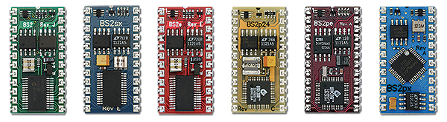
Figure 3.3

3.6.2 POWER ADAPTER CHARGER

This is a device that converts alternating current (AC) from a wall outlet to direct current (DC) that can be used to charge the battery of the lawn mower. The power adapter charger can also regulate the voltage and current to prevent overcharging or damaging the battery. Power adapter charger
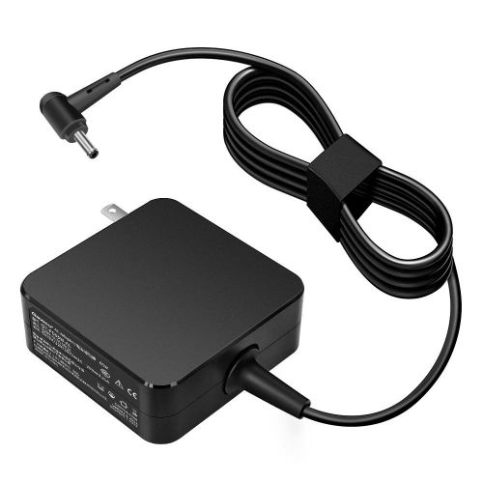
Figure 3.4
3.6.3 12V BATTERY SUPPLY

This is a rechargeable battery that stores electrical energy and provides power to the lawn mower. The battery voltage is 12 volts, which means it can deliver 12 joules of energy per coulomb of charge. The battery capacity is measured in ampere-hours (Ah), which indicates how much current the battery can supply for a given time.
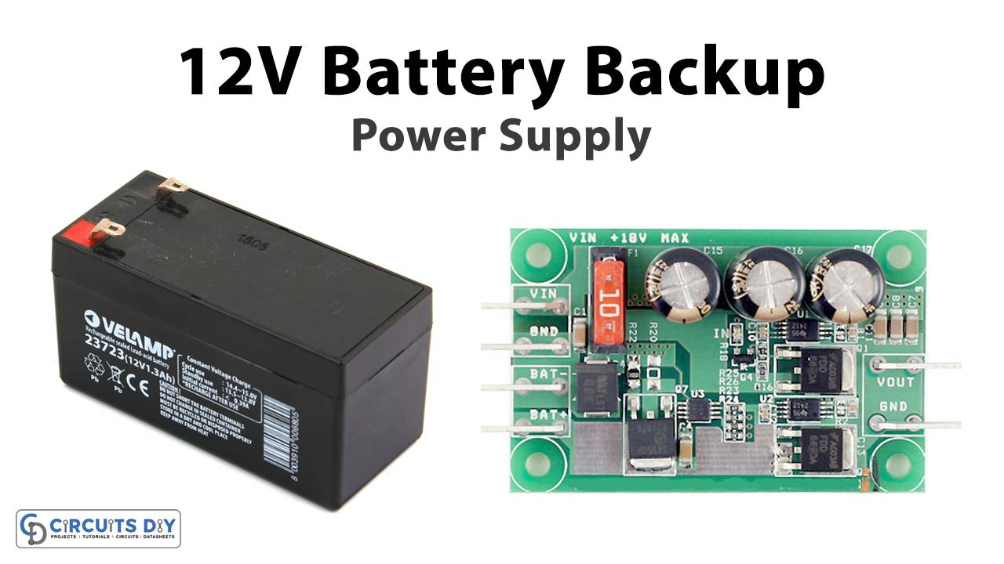

Figure 3.5
3.6.4 ULTRASONIC SENSOR

This is a device that uses sound waves to measure the distance and detect the presence of objects. The ultrasonic sensor emits a high-frequency sound pulse and listens for the echo. The time difference between the emission and reception of the sound pulse is used to calculate the distance to the object. The ultrasonic sensor can also determine if the object is moving or stationary by comparing the frequency of the sound pulse and the echo. Ultrasonic sensor.
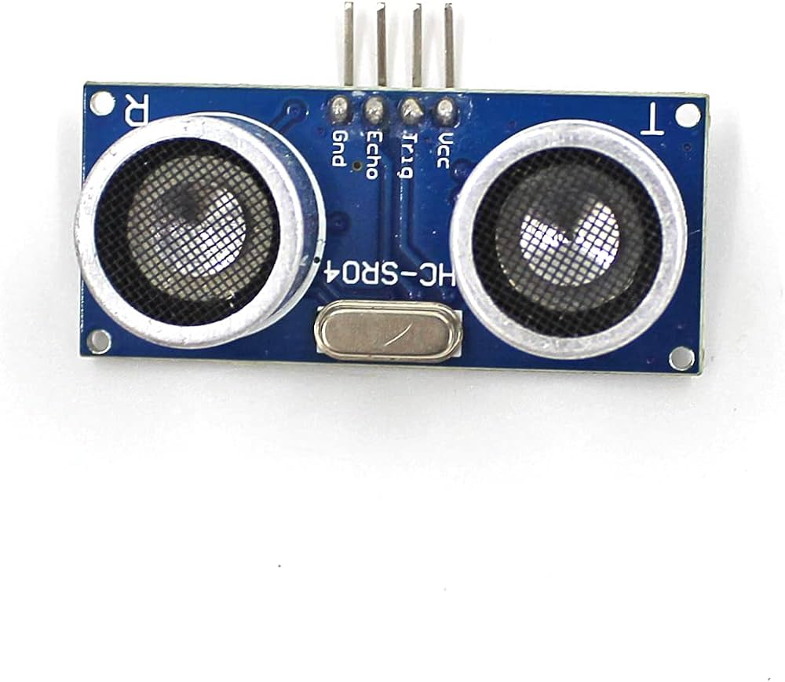
Figure 3.6
3.6.5 5V REGULATOR

This is a device that reduces the voltage from the battery to a lower and constant value that can be used by the microcontroller and other electronic components. The 5v regulator ensures that the voltage is stable and does not fluctuate due to changes in the battery level or the load. The 5v regulator also protects the components from overvoltage or short circuits. 5vPower adapter charger: This is a device that converts alternating current (AC) from a wall outlet to direct current (DC) that can be used to charge the battery of the lawn mower. The power adapter charger can also regulate the voltage and current to prevent overcharging or damaging the battery.
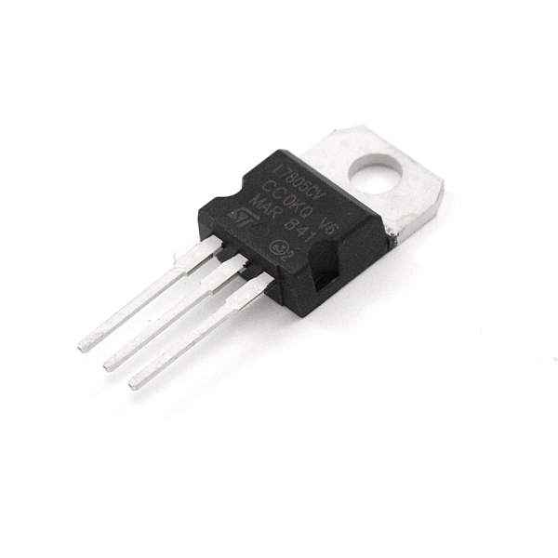
Figure 3.7
3.6.6 CUTTING BLADE DRIVER
This is a device that rotates the cutting blade of the lawn mower. The cutting blade driver consists of a motor, a gearbox, and a shaft that connects to the blade. The motor provides the torque and speed to spin the blade, the gearbox reduces the speed and increases the torque, and the shaft transfers the rotational motion to the blade. The cutting blade driver can also adjust the height and angle of the blade according to the terrain and the desired cutting length. [Cutting blade driver] is an example of a mechanical component in the lawn mower.
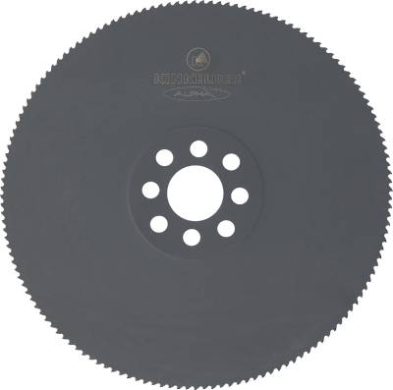
Figure 3.8
3.6.7 MACHINE EYE
This is a device that captures images of the environment and recognizes objects and features. The machine eye consists of a camera, a lens, and an image processing unit. The camera captures the light and converts it into digital signals, the lens focuses the light and adjusts the aperture and zoom, and the image processing unit analyzes the signals and extracts information such as color, shape, size, and location. The machine eye can also perform tasks such as face detection, object recognition, and optical character recognition. [Machine eye] is an example of a vision component in the lawn mower.

3.6.8 L293D MOTOR DRIVER
This is a device that controls the speed and direction of the motors that drive the wheels of the lawn mower. The L293d motor driver consists of a chip, a heat sink, and a circuit board. The chip contains four half-bridges that can switch the polarity and the current of the power supply to the motors. The heat sink dissipates the heat generated by the chip and prevents overheating. The circuit board connects the chip to the microcontroller and the motors. The L293d motor driver can also provide protection from overcurrent and short circuits. [L293d motor driver] is an example of a motor control component in the lawn mower.

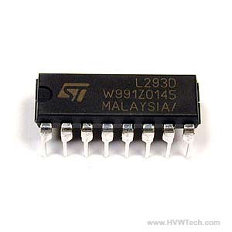
Figure 3.9
3.6.9 DC MOTOR
This is a device that rotates the left and right wheels of the lawn mower. The DC motor consists of a coil, a magnet, a commutator, and a shaft that connects to the wheel. The coil is a wire that carries an electric current and generates a magnetic field, the magnet is a permanent magnet that provides a fixed magnetic field, the commutator is a switch that reverses the direction of the current and the magnetic field, and the shaft transfers the rotational motion to the wheel. The DC motor can also vary the speed and direction of the wheel by changing the voltage and the polarity of the power supply. [DC motor] is an example of a motion component in the lawn mower.
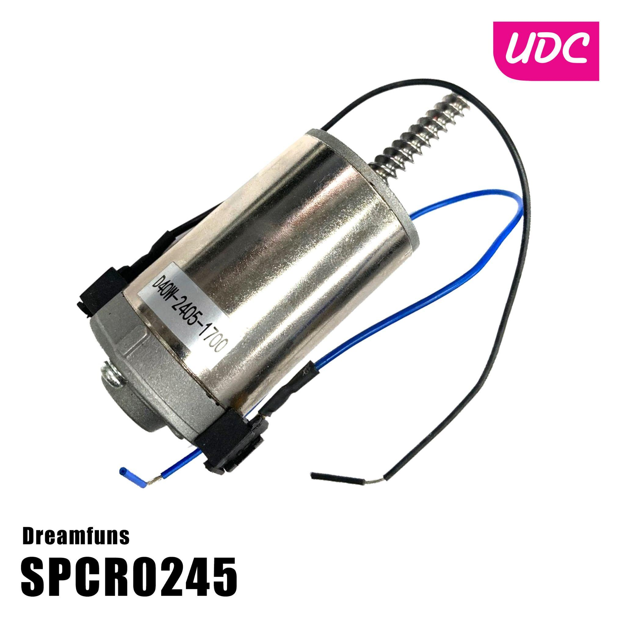
Figure 4.0

